**CHAPTER 6**

**SOFTWARE DESIGN**

**6.1. DFD (Data flow diagram)**

A data flow diagram (DFD) maps out the flow of information for any process or system. It uses defined symbols like rectangles, circles and arrows, plus short text labels, to show data inputs, outputs, storage points and the routes between each destination. Data flowcharts can range from simple, even hand-drawn process overviews, to in-depth, multi-level DFDs that dig progressively deeper into how the data is handled. They can be used to analyse an existing system or model a new one. Like all the best diagrams and charts, a DFD can often visually “say” things that would be hard to explain in words, and they work for both technical and nontechnical audiences, from developer to CEO. That’s why DFDs remain so popular after all these years. While they work well for data flow software and systems, they are less applicable nowadays to visualizing interactive, real-time or database-oriented software or systems.

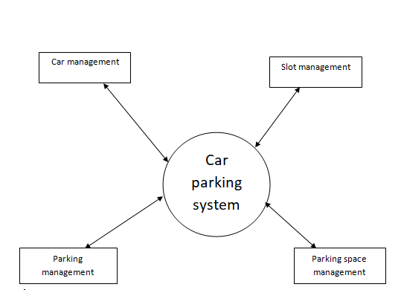

Figure 14: Level 0 DFD

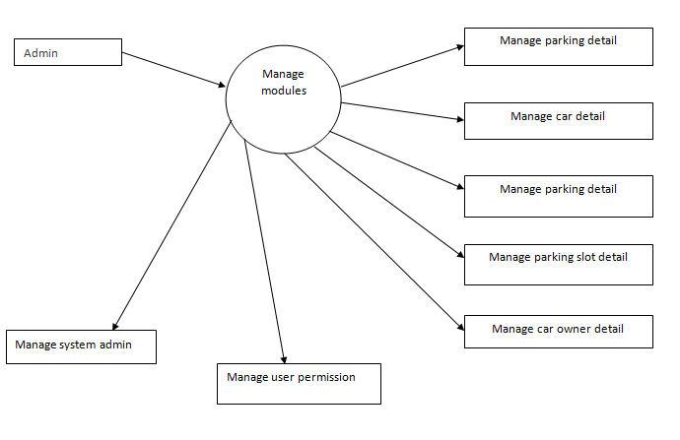Figure 15: Level 1 DFD

**6.2. USE CASE DIAGRAM**

A use case diagram is a dynamic or behaviour diagram in UML. Use case diagrams model the functionality of a system using actors and use cases. Use cases are a set of actions, services, and functions that the system needs to perform. In this context, a "system" is something being developed or operated, such as a web site. The "actors" are people or entities operating under defined roles within the system.

Use case diagrams are valuable for visualizing the functional requirements of a system that will translate into design choices and development priorities

.They also help identify any internal or external factors that may influence the system and should be taken into consideration. They provide a good high level analysis from outside the system. Use case diagrams specify how the system interacts with actors without worrying about the details of how that functionality is implemented.

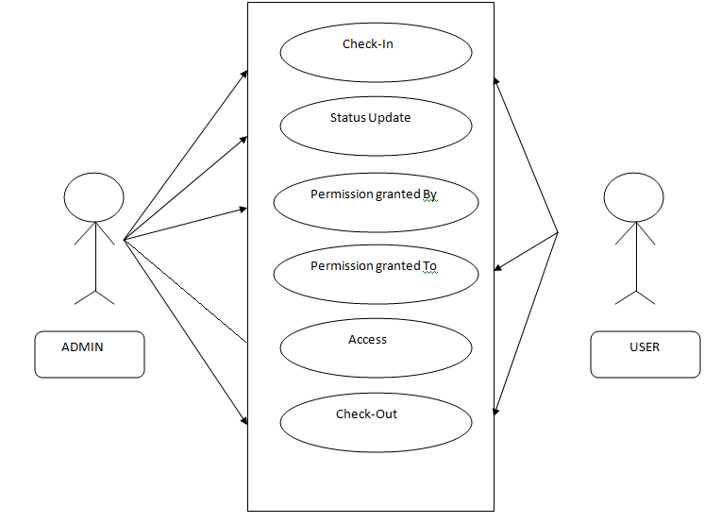

Figure 16: Use Case Diagram

**6.3. FLOW CHART DIAGRAM**

A flowchart is a diagram that depicts a process, system or computer algorithm. They are widely used in multiple fields to document, study, plan, improve and communicate often complex processes in clear, easy-to-understand diagrams. Flowcharts, sometimes spelled as flow charts, use rectangles, ovals, diamonds and potentially numerous other shapes to define the type of step, along with connecting arrows to define flow and sequence. They can range from simple, hand-drawn charts to comprehensive computer-drawn diagrams depicting multiple steps and routes. If we consider all the various forms of flowcharts, they are one of the most common diagrams on the planet, used by both technical and non-technical people in numerous fields. Flowcharts are sometimes called by more specialized names such as Process Flowchart, Process Map, Functional Flowchart, Business Process Mapping, Business Process Modelling and Notation.

(BPMN), or Process Flow Diagram (PFD). They are related to other popular diagrams, as Data Flow Diagrams (DFDs) and Unified Modeling Language (UML) Activity Diagrams.

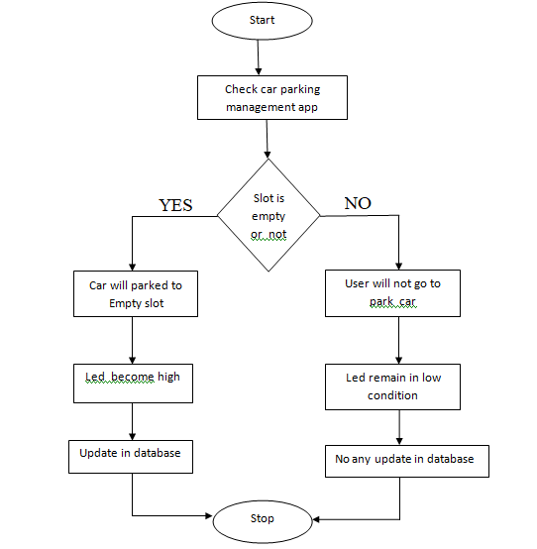

Figure 17: Flow Chart Diagram